UNIVERSITY OF CRAIOVA
FACULTY OF AUTOMATION, COMPUTERS AND ELECTRONICS

DOCTORAL THESIS

- Summary-

FAULT DETECTION AND LOCALIZATION ALGORITHMS IN LARGE POWER GROUPS
-- CONTROL IN FAULT CONDITION-

Scientific Coordinator:
Prof. dr. ing. Mircea IVĂNESCU

Candidate for a doctor’s title:
Camelia MAICAN

-2009-
The issue of fault detection and localization is rather complex. The facts provided by the reality of industrial systems to the engineer who is in charge with the monitoring functions are usually inadequate: a small number of available models, lack of redundancy, insufficient number of measurements, disturbances that are not modeled. The detection and diagnosis of the faults play an increasingly important role in industrial processes. The dynamic modeling of the equipments is a well developed area, thus the models based on diagnosis methods can be efficient and easily applied.
The opportunity of detecting the faults in any industrial equipment highly depends on the availability of performing adequate measurements. For the super heaters, the associated variables from / to the output flow rate of the equipment (flow rates and temperatures) are frequently being measured, but the measurements along the equipments are rarely available. Therefore, the opportunities of space fault localization are limited.
The fault detecting possibilities in any dynamic process become more and more complex and thus there is an increase in the demand for detection and diagnosis, aiming at providing a safe continuous operation. Fault detection through various residual generation methods is a sign that something is going wrong within the system.
In other words, the detection and diagnosis of the faults is an early display of incipient faults, which can help in avoiding the major faults and system calamities and in taking the adequate measures in order to maintain the system operation. The main task of the fault compensation is modifying the normal configuration mode, with the goal of compensating the faults (if possible) by activating the back-up systems.
We can state that fault detection and compensation is one of the most critical issues in the operation of the high performance systems, as thermo-electrical power stations, chemical processes, vehicles and so on.
The purpose of the thesis is to detect and locate faults in the control systems of the power plants that can not be detected by the existing signal protection and inter-blocking structures, and to provide control strategies within fault conditions.
The thesis is structured into 8 chapters:
Chapter 1, Analysis of the Existing Control Structures, presents the hierarchical control structures, the automation prerequisites assessed in the thermo-electrical power stations of the energetic system and the monitoring and advanced control systems – the PROCONTROL module – implemented within Işalniţa and Turceni thermo power stations.
In order to reduce the risk of stopping the plant due to equipment breakdown, it is recommended that the control tasks are distributed along functional levels with independent equipments at each level. Thus, an increase of information processing speed and of drawing decisions is being ensured, by using specific equipments and programs.
The automated control system is made up of a series of measurement and control equipments, having the role of ensuring a safe efficient operation of the electrical power station, which would comply with the national energetic system. These requirements may not exceed the safety and operation restrictions of the plants in the energetic group. Furthermore, the plant’s operation must comply with the environmental protection regulations.
The automated equipments have to ensure the manual and automatic control of the energetic groups by:
- Maintaining the plants within the safety and operation restrictions;
- Monitoring the limits and operation constraints and ensuring immediate assignments and permanent recording of the parameter values;
- Signaling and reporting to the operator through the alarm system about the proximity to the breakdown limits;
- Automatic stopping of the plants if the operating restrictions have been exceeded.
The automatic control system of the energetic group must ensure two types of tasks: system tasks, enforced by the energetic system or by the consumers and local or group tasks, enforced by the internal group safety.

Chapter 2, Protection and Inter-Blocking Systems for the Thermo-Energetic Groups, presents the steam boilers protection functions and the turbo-aggregates auxiliary functions, as well as the conditions that must be satisfied in order to operate the steam boiler.
The steam boiler protection system (signaling and inter-blocking) ensures the monitoring of its appointed parameters and makes decisions, depending on the fault type:
- steam boiler putting off with operator ’s noticing ,in case of major faults;
- informing of the operator of the other faults. In this case, the operator is the one who makes the decisions; for the advanced software systems, possible solutions can also be presented.
The signal for each protection wire comes through three different channels, each channel entering in a different way. The operation of the steam boiler takes place when one of these protections gets over the set operating conditions (maximum or minimum) or changes its state (on /off), two of the three channels.
Chapter 3, Fault Detection and Localization Methods, a series of fault detection methods are being presented (linear systems based on standard models, multiple filters methods, fault detection using the analysis of direct and reversed sensibility) and the implementation opportunities of these methods for steam boilers are being analyzed.
Within the methods based on standard models, there were presented methods for the fault detection in the estimation of parameters, for the fault detection with observers, fault detection with parity equations. There is also a comparative study of the use of such methods stating the matters to be taken into account for their proper application.
Depending on the nature of the process, equipment or control system, specific fault detection and localization methods have to be used, while taking into account the technologies that have been used.
Systemic analysis of the methods of fault detection and localization developed up to the present time has allowed on one hand the possibility of choosing the variants implemented in the case of steam boilers and the development of specific new methods on the other hand.
Chapter 4, Faults Detection and Localization for Steam Over-Heaters, presents the automatic control structure of the steam temperature and the reconfigurable control structure in case of fault sensors. Based on the technological flow of steam super heaters one can determine the mathematical model and implement the faults detection and localization structures for both actuators and sensors.
The fault detection structure of the actuators is adaptive because it always compares the variable outputs of the simulator with the variable outputs of the process. We considered the cases when one of the actuators is damaged, when two actuators are damaged or all the actuators are damaged and we succeeded in detecting and localizing the fault.
There have also been detected and localized faults occurring in sensors, within several situations, such as: breaking the link with the sensor, fault sensor from the very beginning and fault sensor after a time moment t, since the beginning of operation.
All these methods have been verified by simulations under Matlab Simulink.
In order to check the fault detection and localization structures in real-time ,it has been used a super heater electronic simulator, which has been developed on equations of heat transfer taking place in real, thus outlining some factors related to the main communications analog and digital equipment and the sensors and reverse calculation of the computing equipment and the actuators.
Our purpose was to represent a certain level of process temperatures within the voltage in various points of the simulator and ensure the same time values as in the real process.
Using BORIS blocks (software simulation of the control structures on the real process) and Laybold Teaching acquisition board, it was realized a detection structure of the faults that appeared to the actuators of the electronic simulator, as the one in the figure below.
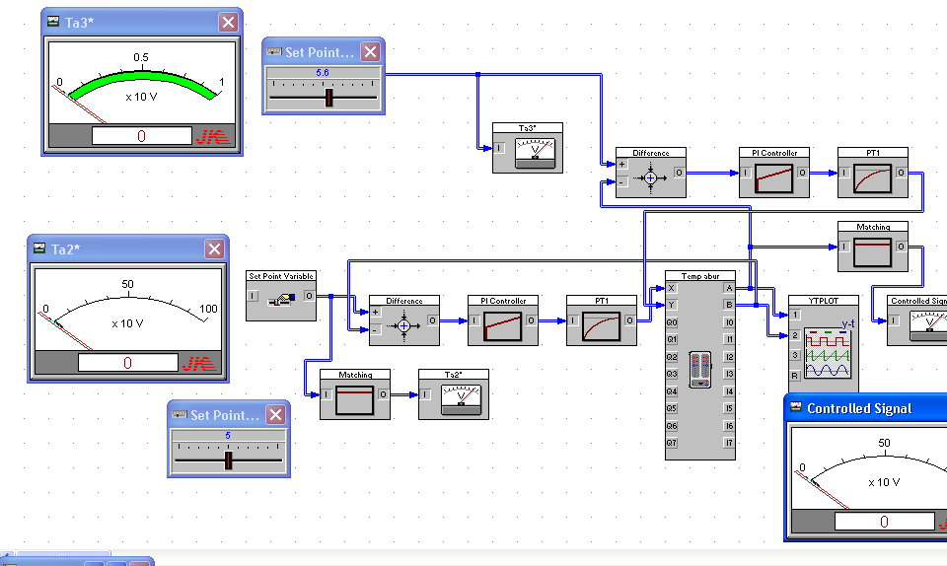
Fig. 1 Fault detection structure implemented under BORIS
A similar study is being proposed for the heater in Chapter 5, Fault Detection and Localization at the Heater System (Combustion + Vaporization). This chapter analyzes and determines the faults that may occur within the actuators and the plant. The technical flow of the heating system is analyzed and the mathematical model of the system is established. And in this chapter are analyzed and determinate the faults that can occur:
* in the burning process:
- the variation of the calorific fuel
- the variation of the heat transfer coefficient by convection and radiation.
* at the actuators:
- blocking
- the variation of the transfer factors.
* at process:
- the number of burners in operation
- the variation of the calorific fuel
- the variation of fuel flow B
- the variation of excess air
- the burning rate
- the variation of gas flow.
The response of the system in normal operating conditions was compared to the response system in various situations of fault operation.
Experimental results have been obtained under MATLAB Simulink.
In chapter 6, Fault Regime Control, is presented the reconfiguration problem to the fault actuators or fault sensors.
The scheme for fault tolerant control is shown in Figure 2.
Process
Fault tolerant controller

Fig. 2 Fault tolerant system
The control law is designed so that the closed loop system verifies the process faultless. Before the appearance of a fault, the level of supervision is not active. Adaptation of the controller of the faulty system is achieved at the level of supervision. If the actuators and sensors operate differently, but still failed controllable and observable, setting adjustments may remain unchanged, but the controller parameters should be adapted to the fault.
If a fault actuators or fault sensor, breaking the control loop, it can be use a new implementation, and a new sensor. Then controller must be reconfigured in the sense that all processes of selecting the appropriate configuration and adaptation of the controller’s parameters should be repeated after the fault.
The severe faults such as failure of the actuators or the sensors interrupt the control loops which can not be made by the nominal regulator. In order to maintain the system in operation, it is necessary to use a different set of signals input and output to achieve the control task, realized a new structure of control. Once selected new structure of control, must find the parameters of the new controller, the new configuration corresponds to the transfer function of the fixed part of the system. Reconfiguration goal is to stabilize the failed process and to maintain operational on satisfactory performance, preventing catastrophic damage.
In this chapter are presented the analytical methods to compensate for the effects arising from faults in the actuators, respective sensors with application to the superheater of the steam boiler. Also in this chapter is presented a control structure in fault condition to the electronic simulator’s actuators and sensors, using the software BORIS and the acquisition board Laybold Teaching.
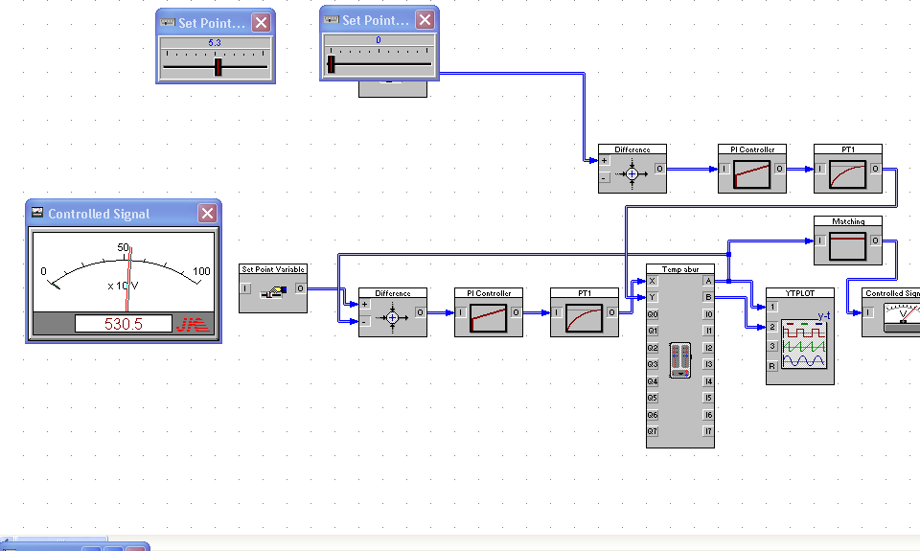
Fig. 3 Control structure in fault condition under BORIS
For the burning process is proposed a structure to optimize the flow of air from the steam boiler according to the operation (normal or transitional), and depending on the concentrations of CO, O₂ and smoke measured in different points of the plant.
At the same time this scheme allows detection of faults in the burning process.
Chapter 7, Increasing Of The Control Systems Robustness, hardware and software methods are presented, with the goal of increasing reliability and faults management in automatic systems.
Detection of faults is a necessity to avoid the consequences arising from the failure of some component.
Fault tolerant systems are known in the massive future development and what is today only one additional quality will soon become a prerequisite.
Methods of increasing reliability are to use fault tolerant systems and supervision and management failures.
Literature distinguishes two ways of achieving fault tolerant systems:
- Systems with static redundancy
- Systems with dynamic redundancy.
Advanced methods are needed for supervision, fault detection and diagnosis of these. These methods must meet the following requirements:
• early detection of minor defects, with the behavior suddenly or early in time;
• diagnosing faults in processes or parts of processes and handling devices (action items) and measuring equipment (sensors);
• fault detection in closed loop;
• overseeing the processes in transient states.
The system of automatic defect management consists of:
- fault tolerant actuators
- fault tolerant sensors
- fault tolerant active controllers
- module of faults detection
- module of faults management.

Personal contributions brought to the area of faults detection and localization and fault regime control are being presented in Chapter 8, Conclusions and contributions.
The main contributions comprised in the present thesis have materialized in:
Analysis of the control, monitoring, signaling and protection system, aiming to:
- establish the detection and localizing functions for the system, implemented at the thermo-energetic groups;
- determining the measured values from the process;
- analysis of the faults that have so far occurred at the plant and at the equipments;
- setting of the extension opportunities of the system’s functions in the area of fault detection and localization;
Analysis of the fault detection and localization methods developed so far and of the opportunities of implementing them at the thermo-energetic groups, applying to:
- actuators;
- transducers;
- controlling devices.
Applications have been developed by simulation on the equipments where a series of possible faults were intended to be detected. The surveyed equipments were:
- the burning process;
- the heaters.
Controlling opportunities during the fault regime were explored:
- hardware availability – by doubling or tripling the number of actuators and transducers;
- analysis and description of the control systems from the Işalniţa and Turceni thermo power stations;
- control by using other command modes – for example MIMO.
The present thesis suggests a compensation structure for the effects generated by failures at the actuators in the over-heater system at the steam boiler, verifying on the electronic simulator and the BORIS software.
A compensation structure of the feed-forward faults was developed, verified by simulations in Matlab Simulink. This compensation structure allows the detection and the localizing of the faults, as well as the control in a fault regime, by ensuring the feed-forward value.
An air flow rate optimizing structure in the steam boiler has been developed, depending on the operation regime (normal or transitory) and on the CO, O₂ and smoke concentrations, measured in several points in the plant.
The thesis presents fault management methods by connecting the fault tolerant components, resulting an online and real-time operating system.

